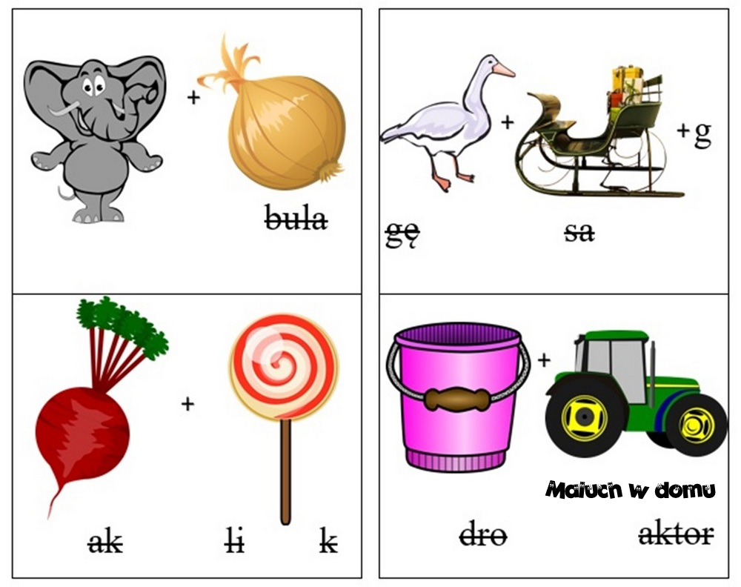
Hasło …………………………………………………………………………….
……………………………………………………………………………………

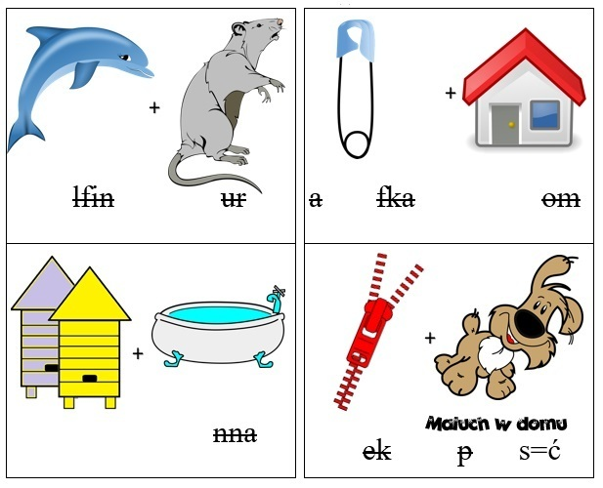
Hasło…………………………………………………………………………………………………………………………………………………………………….

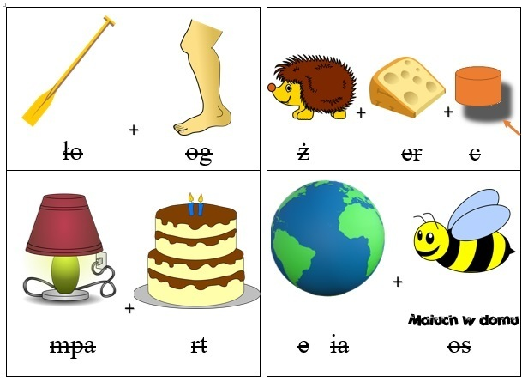
Hasło………………………………………………………………………………………………………………………………………………………………………………………………………………………………………………………….

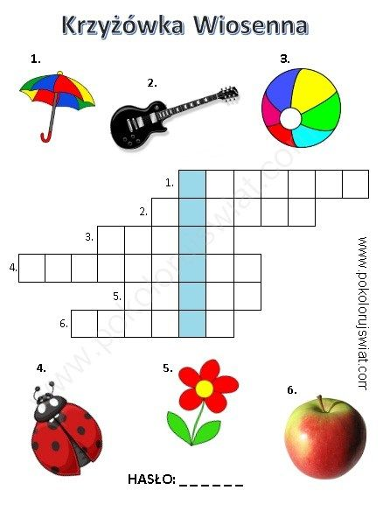
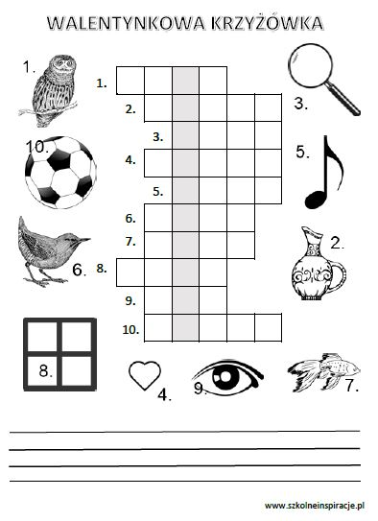
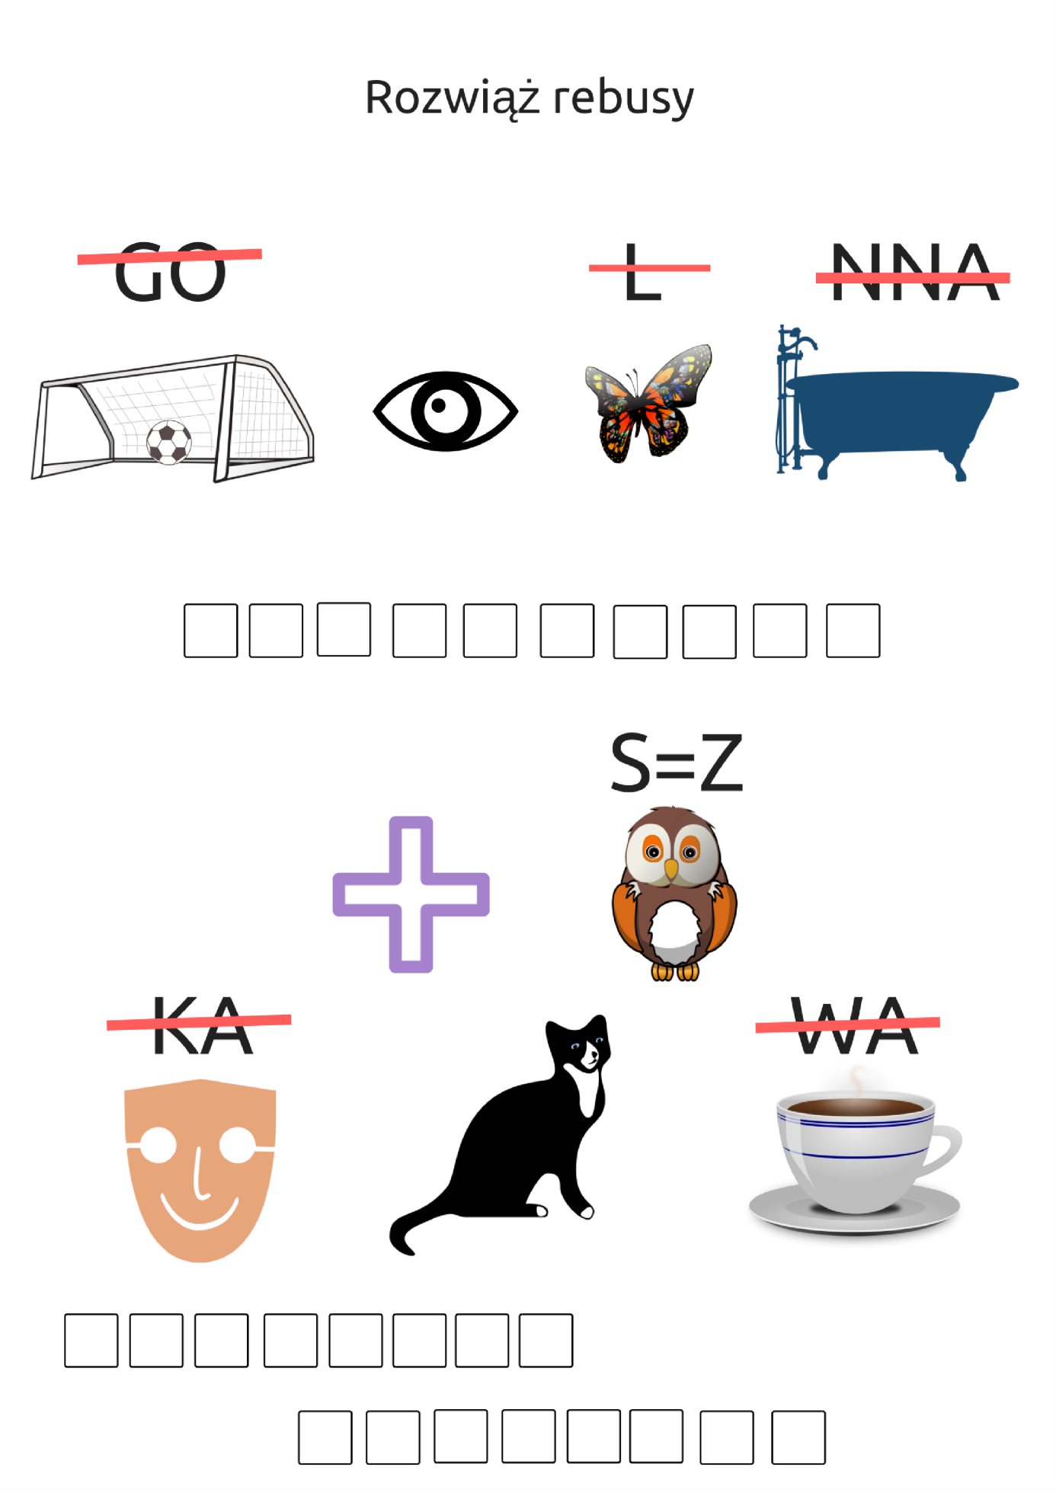
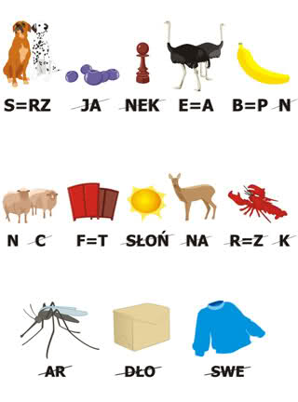
Hasło……………………………………………………………………………………………………………………………………………………………………………………………………………………………………………………………………………………………………………………………………………….

